Exam ALGO3-10/Dec/2026
Exercise 1: (Sequential structures) (10 pts)
- Given two stacks of integers S1, S2 known by their basic operations presented in the course (like their exact presentation in the course), give a function « SearchStack (e: integer): Boolean; »which searches for an integer e in S1. S2 can be used by the function to restore S1 to its initial state after the function ends. Use indices 1 and 2 to

- Same question but for two queues Q1, Q2 and a function « SearchQueue (e: integer): Boolean; ». (5pts)

Exercise 2: (Hierarchical Structures). (10 pts)
Consider the following values: 5, 10, 16, 30, 14, 18, 3.
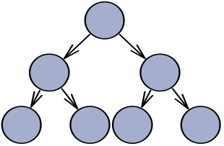
- Fill the following graphs according to successive additions of these values in a heap. (2pts)

- Show the steps of one deletion in that heap (1pts)

- Fill the following graphs according to successive additions of those values (as keys) in a BST. (2pts)

- What do you think about the last result in the BST? (1pt)
- What is the problem with this result? (1pt)
- Propose the basic steps to manage this problem (3pt)

